ONLINE EASTBAY AUCTIONS BUSINESS



|  |  |  |  |
| --- | --- | --- | --- |
| No. | Name | Student ID | Email |
| 1 | Artiman E. Deilami | kn4538 | adeilami@horizon.csueastbay.edu |
| 2 | Pooja Bhansali | gs6262 | pbhansali@horizon.csueastbay.edu |
| 3 | Pradeep Gupta | vs2545 | pgupta5@horizon.csueastbay.edu |
| 4 | Rashmi Pandit | ie8656 | rpandit3@horizon.csueastbay.edu |
| 5 | Sanjith Ramesh | nf2544 | sramesh6@horizon.csueastbay.edu |

|  |  |  |
| --- | --- | --- |
|  |  | Pages |
| 1 | **Title Page** | 1-2 |
| 2 | **Summary** | 3 |
| 3 | **Introduction** | 4-8 |
|  | **Model Formulation** | 9-15 |
| 4 | **Main Chapter** | 16-27 |
| 5 | **Conclusion** | 28 |
| 6 | **Recommendations** | 30 |

**SUMMARY**

The optimization model presented is to maximize commission at EastBay Auctions, Inc. which is an online auction business company. The optimization model consists of two models which are High Value Listings and Low-Medium value listings of item prices. In both of these cases, the objective function is to maximize the commission.

In the presence of item value, mean value, number of auctions, bid start price (average), the final bid price is calculated, and the commission is based on the final bid price. Using the historical data a commission optimization model to maximize commission from the auction process is created. The following information has been obtained for use in constructing the model. The formula to calculate the maximum commission is given by C = [ final value * 5 percent of final bid price] or $5 whichever is higher.

In the case of High Value listings (HVL) the commission obtained largely depends on the number of auctions in the greater than $1000 category. In other words, there is a focus on accommodating more number of high value listings to maximize commission.

In the case of Low-Medium Value listings the commission obtained largely falls in the category where the number of auctions is more for items whose price falls in the $1 to $1000 category. This approach is more customer centric in that it accommodates more number of items priced between $1 - $1000(Low-Medium Values).

Although the commission obtained for individual items in low-medium value listing is typically lower than High Value Listings, due to the volume increase in the number of auctions per day it yields a higher commission than in High Value Listings.

Microsoft Excel is used to formulate the model and then Solver Table add in used to optimize commission and obtain a one-way and two-way sensitivity analysis to learn more about the model’s constraints and relationships.

EastBay Auctions Inc. will need to decide if it wants to adopt our business recommendations.

**INTRODUCTION**

**Company**

By far the largest online auction host is eBay, a company founded in 1995 and through which an estimated 95 percent of all online auctions took place in 2018. Other online auctioneers such as Amazon; Liquidity Services, Inc.; Overstock.com; uBid; and Yahoo are our company’s competitor. EastBay auction management team determined that the best way to compete with these auctioneers are to reduce the company's cost and lower commission rate on final price which can attract more auctioneers and lead to increase companies total number of auctions. East Bay Inc.is also exploring the option of focusing more on having high value listings on their website.Values from $01 to $999 are considered as Low Value listing to Medium Value listing and Values which have listing of over $1000 are considered as a ‘High Value’ listing. East Bay Auction planned to use web influencer instead of traditional advertising methods like Newspaper, Flyers and even Television. Since the web influencer are very popular among the younger generation the company management assumed, they could take advantage of this powerful source for company’s advertisement.

Online auction has its related cost which consists of some fixed cost ( licensing, Domain name, Application development and maintenance) and some variable cost (which depend on the number of auctions, Since we are storing some photos and description about the items the storage will vary based on the number of auction) But most of the time they are usually limited to a small percentage of the company’s total income. we reduce the estimated cost from our commission, therefore our 5% commission rate is the company’s benefit from selling an object in an auction.

**Problem**

The goal is to build an optimization model for maximizing commission at EastBay Auctions, Inc. To increase the commission, the site needs to have more bidders. The auction site consists of data which includes items prices, number of auctions, average bid start price and final bid price. The final bid price is obtained using a polynomial function. The items listed on the auction site are grouped bins of prices ranging from $1-$19, $20-$49, $50-$99, $100-$499, $500-$999 and above $1000. There is a limit on the total number of auctions that can be handled by the site each day and the limit changes for the strategy followed.

For Strategy

(a) Due to this constraint the auction site wants to limit the number of auctions for values under $500 as they do not result in high commission. East Bay Inc. wants to encourage the number of auctions for higher values $1000 and above.

(b) For this scenario the company wants to encourage the number of auctions which are below $1000 and has a fairly normal listing of all listings prices.

**Business Background**

An auction site is a marketplace for buyers and sellers to exchange goods using the auctions approach. The success of such a marketplace depends on having a large enough number of participants and having a good balance of buyers and sellers with available demand and supply of items. The key performance metrics for the overall business would be the number of transactions in the marketplace and the total amount of money exchanged in the transactions. Key business decisions would be related to achieving the goals of increasing the number of transactions (items sold) and transaction amounts (item price). Eastbay Auctions is trying a number of strategies to achieve the above goals.

**Strategy**

The project of our group is based on business of an online auction company, whose goal is to maximize commision. East Bay Auctions Inc. is a new auction company which has a two fold strategy:

a)Target high value listings to be accommodated on the website (Values which have listing of over $1000 are considered as a ‘High Value’ listing).

b)Have a more customer centric approach where low to medium value listings are accommodated on the website. (Values from $1 to $999 are considered as Low Value listing to Medium Value listing).

All of these goals will have different parameters to address and strategies will be different. We will address a portion of these goals through optimization model and will address some other using solver table analysis.

Constraints are on number of auctions per day, auction item listing price, minimum bid price, commission kept by the auction company as percentage of auction amount. Final bid price will be shown as a polynomial equation based on limited past data. Auction company has decided that they will take a commission of 5% of final bid on all auctions.

**Proposed Solution**

Based on the first strategy, for high value listings the company wants to have more bids that are over $1000 and is targeting high value listing items to maximize the commission earned. In this scenario the majority of the commission is earned on high value items listed (=>$1000) on the website. Although the number of auctions will be low, the commission earned is higher for high value items.

Based on the second strategy also called a customer centric approach. For low-medium value listings the company wants to have more bids that are between $1 and $999. The company is targeting the Low-High Value listing items to maximize the commission earned. In this scenario the majority of the commission is earned on low-medium value listings ($1 to $999) on the website. Although the commission earned is low for these items, the number of auctions per day increases sizably. The total commission earned per day is more than that of High Value Listings.

**INPUTS:**

X: Item Value : Item Value in Auction x= (x1,x2,x3...x6)

X1= Item value in the range of $01-$19

X2 = Item value in the range of $20-$49

X3= Item value in the range of $50-$99

X4 = Item value in the range of $100-$499

X5 = Item value in the range of $500-$999

X6 = Item value greater than $1000

Y: Average of Item Value y = (y1,y2,y3 ...y6)

Y1= Average Item value in the range of $01-$19

Y2 = Average Item value in the range of $20-$49

Y3= Average Item value in the range of $50-$99

Y4 = Average Item value in the range of $100-$499

Y5 = Average Item value in the range of $500-$999

Y6 = Average Item value greater than $1000

Z: Number of Auctions : Decisions Variables

A: Bid Start Price = [=IF((50/100)*Y<5,5,(50/100)*Y)]

B: Final Bid Price = [Y*120%]

C: Commissions =ri =IF((5%)*B<5,5,(5%)*B)

D: Optimize to Maximize the total Commissions = Decisions variable* Commission

E: Constrains:

1: Item Value ($01-$19 Range).

2: Item Value ($20-$49 Range).

3: Item Value ($50-$99 Range).

4: Item Value ($100-$499 Range).

5: Item Value ($500-999 Range).

6: Item Value ($>1000 Range).

5: Total Item Value Under $50.

6: Total Item Value Under $500.

7: Total Auction Value.

ALL Decision Variables are NON-ZERO and NON-NEGATIVITY

**MODEL FORMULATION**

**STRATEGY PLAN A: High Value Listing**

**Decision Variables:**

|  |  |
| --- | --- |
| V (In Groups) | Average Item value V |
| A: Bid Start Price | [=IF((50/100)*Y<5,5,(50/100)*Y)] |
| B: Final Bid Price | [Y*120%] |
|  |  |

**Objective Function:**

|  |  |  |
| --- | --- | --- |
| Max Commission | Σ[Final price * 5%] or $ 5 whichever is greater fee | The optimization model presented is to maximize commission at EastBay Auctions, Inc. which is an online auction business company. |

**Constraints:**

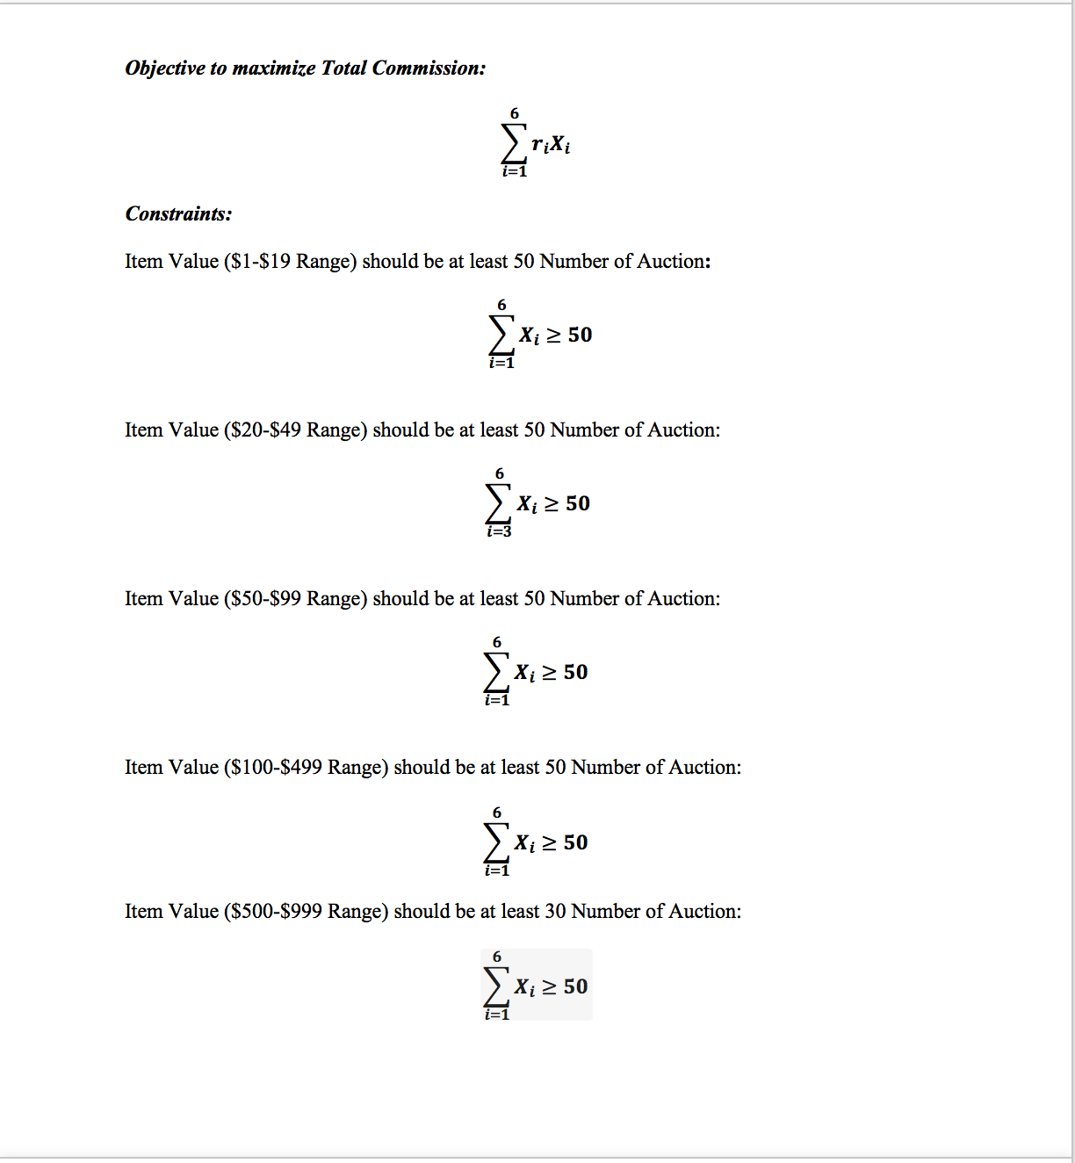

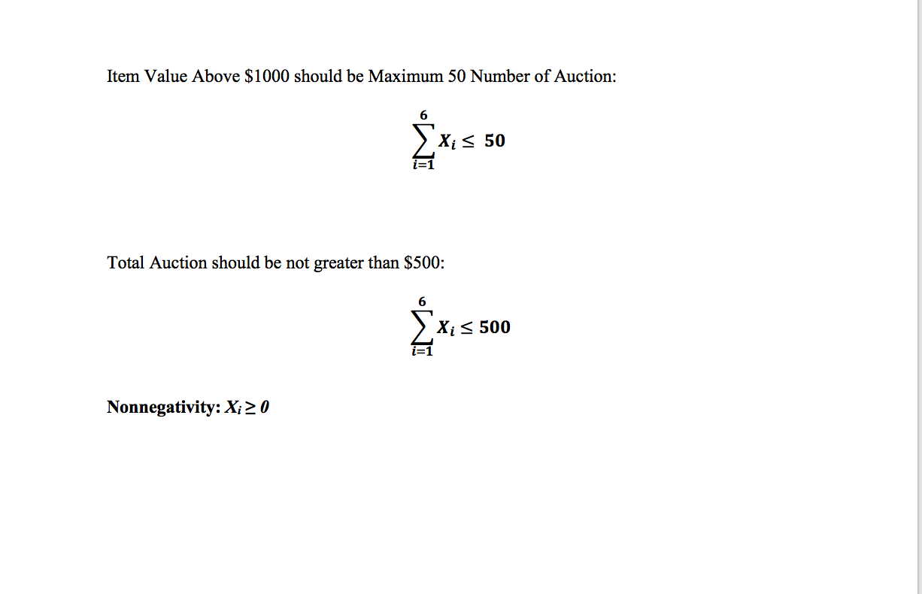

|  |  |  |
| --- | --- | --- |
| **Constraints:** | **Equations** | **Explanation** |
| Item Value $ (1-19 Range) should be at least 50 | **X1 >= 50** | **we will target the Average item value range between $ 1-19 and minimum number of auction should be 50** |
| Item Value $(20-49 Range) should be at least 50 | **X2 >= 50** | **we will target the Average item value range between $ 20-49 and minimum of number of auction should be 50.** |
| Item Value $(50-99 Range) should be at least 50 | **X3 >= 50** | **we will target the Average item value range between $ 50-99 and minimum of number of auction should be 50.** |
| Item Value $ (100-499 Range) should be at least 50 | **X4 >= 50** | **we will target the Average item value range between $ 100-499 and minimum of number of auction should be 50.** |
| Item Value $ (500-999 Range) should be at least 50 | **X5 >= 50** | **we will target the Average item value range between $ 500-999 and minimum of number of auction should be 50.** |
| Item Value $ (above 1000 Range) should be at least 50 | **X6 >= 50** | **we will target the Average item value range greater than 1000 and minimum of number of auction should be 50.** |
| Total Auction Per Day should be maximum 500 | **(X1+X2+X3+X4+X5+X6) <= 500** | **we will target the Sum of all Average item value range and Maximum of number of auction should be 500.** |
| Non-Negativity | **X1,X2,X3,X4,X5,X6 >= 0** | **To keep all the variables greater or equal to Zero.** |

**STRATEGY PLAN B: CUSTOMER- CENTRIC**

***Decision variables: Xi :*** Number of Auctions Xi = [X1,X2,X3,X4,X5,X6]

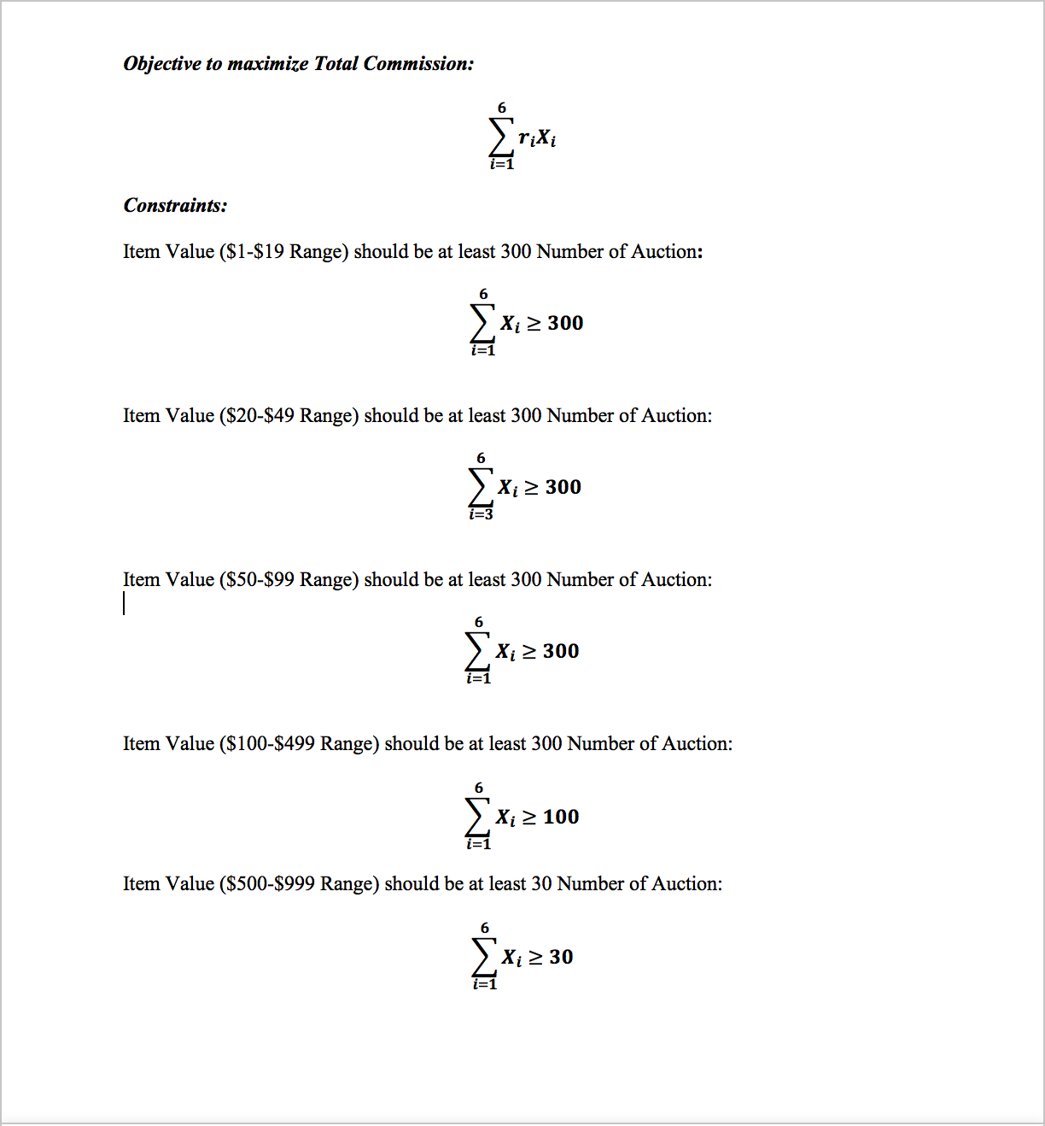

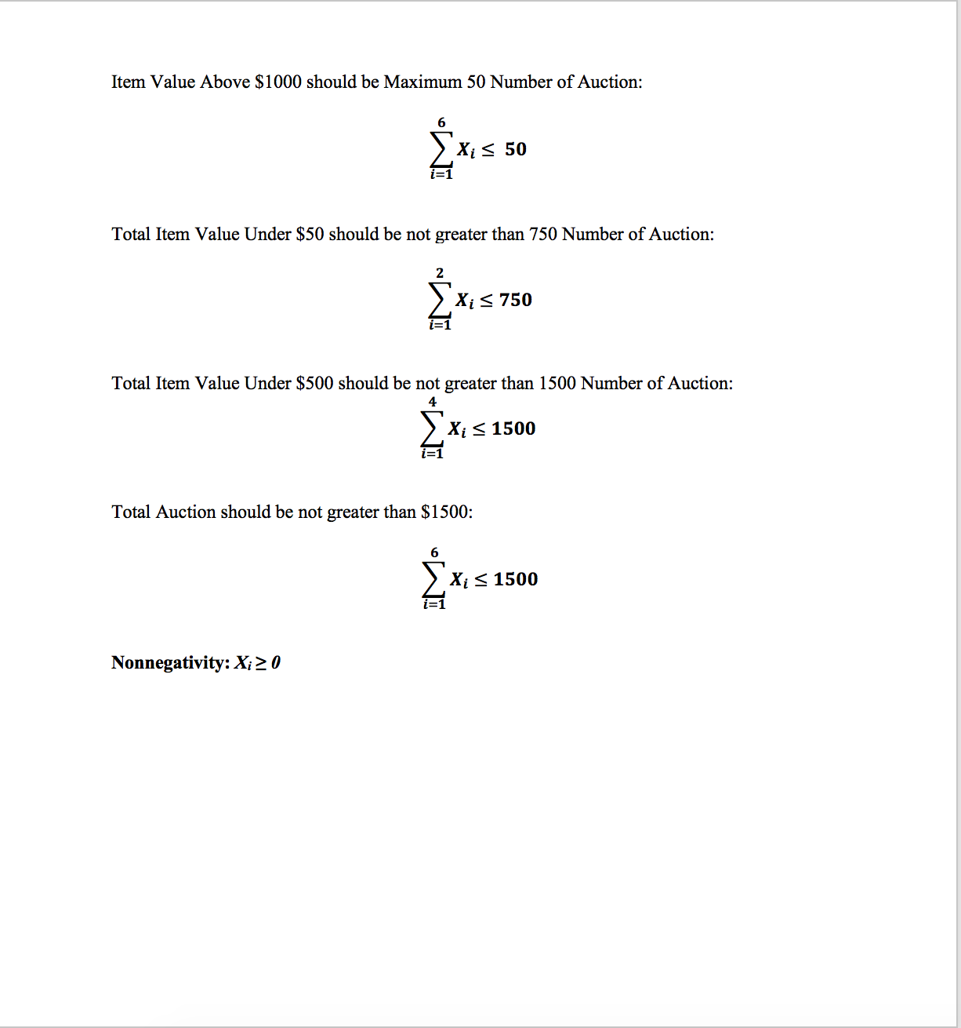

**MAIN CHAPTER**

**Data Collection:**

The data available for EastBay Auction, Inc. contains data Item value, Starting Bid price, Number of auctions, final bid price and commissions. The Final bid price is based on the historical data collected and it is the result of a polynomial function.

**The Elasticity of Demand Function:**

**y = 8E-05x2 + 1.7474x + 69.158**

**R² = 0.9922**

|  |  |
| --- | --- |
| **Linear Function** | **0.9891** |
| **Exponential Function** | **0.6167** |
| **Logarithmic Function** | **0.5049** |
| **Polynomial Function** | **0.9922** |
| **Power Function** | **0.9829** |

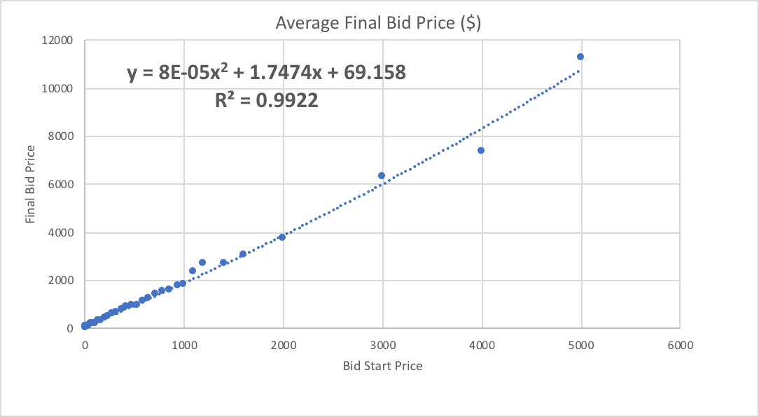

**We are getting higher value in Polynomial equation from the trendline by the degree of the largest exponent. The degree of the polynomial trendline can also be determined by the number of bends on a graph.**

**Strategy A: HIGH VALUE LISTING**

As shown in Figure 1, No. of Auction and commissions. Blue color blue (Series 1) indicates the Number of Auction and Orange color (Series 2) Indicate the Commision getting based on the Final Bid Price. So we can analyze that Higher value listing, when there is a higher number of auction, company can get high commission on each item, so company should on advertising so buyers get aware about the auction of items and target them.

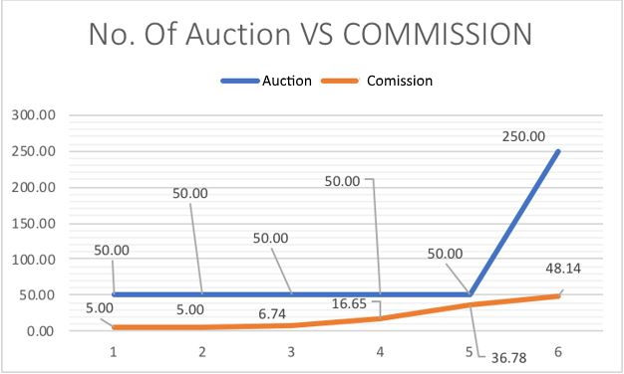

**Strategy B: Customer Centric**

The data available for EastBay Auction, Inc. is contained in a data Item value, Bid price, No. of auction and final bid price and commissions. Research for data collection started with identifying the maximization the commission getting from each item selling. As shown in Figure 1, No. of Auction and commissions. Blue color blue (Series 1) indicates the Number of Auction and Orange color (Series 2) Indicate the Commission getting based on the Final Bid Price. So, we can analyze that when there is a higher number of auction, company can get high commission on each item, so company should on advertising so buyers get aware about the auction of items and target them.

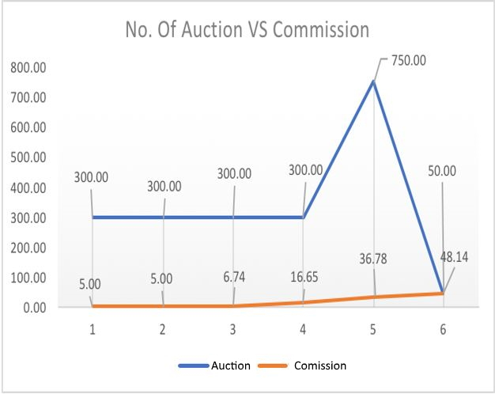

**Solution Results and Analysis**

**STRATEGY PLAN A: HIGH VALUE LISTING**

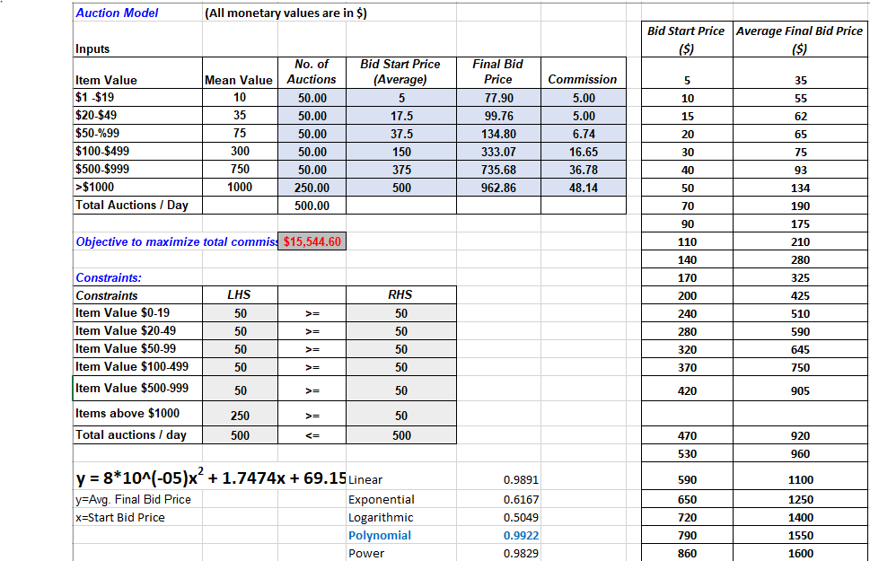

Objective functions = $ 15,544.60

In this model all our constraints met and Total Item Value above $ 1000 is non-binding solutions.

Running the model using NRG Nonlinear in Solver had quite a different and welcome result.

Using solver table on this model, we study how the optimal Commission profit function varies, with changes in the No of the auctions of the each item, start bidding price and Final bidding price.

**ONE WAY ANALYSIS FOR SOLVER MODEL IN HIGH VALUE LISTINGS WORKSHEET:**

Cell C12 is our Objective function which indicates the total number of commission:

**EXPLANATION**

1) At auction number 250 and below the objective function is violating one of the constraints, therefore it is not feasible. As the total number of auctions per day increases from 300 to 750 (increment of 50), we can see that objective function increases by a constant amount of $2407, thus the objective function is sensitive to variations in the total auctions per day (input parameter).

For the decision variables of $01 to $999, the objective function is insensitive to variations in the 'total auctions per day' (input parameter). If the decision variable is 'greater than $1000', the objective function is sensitive to variations in the 'total auctions per day' ( input parameter). As the total number of auctions per day increases from 300 to 750 (increment of 50), we can see that objective function increases by a constant amount of $2407, thus the objective function is sensitive to variations in the total auctions per day (input parameter).

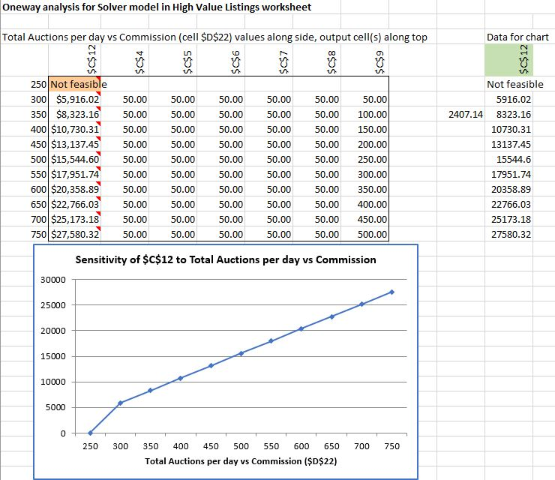

**TWO WAY ANALYSIS FOR SOLVER MODEL IN HIGH VALUE LISTINGS:**

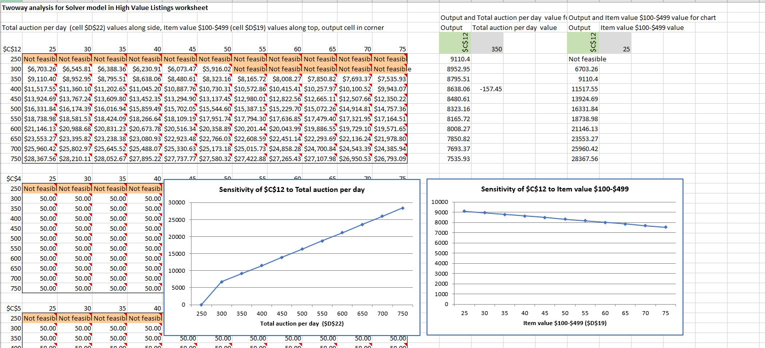

**INTERPRETATIONS:**

1) CellC12 is the objective function. When item value is between $100 to $499 (and the constraint variation is between 25 to 75), the objective function is decreasing by a constant amount of $157, thus we can see that objective function is sensitive to variations in the total auctions per day (input parameter). When item value is between 25 to 75, there is a negative effect on the objective function.

2) CellC12 is the objective function. When the total number of auctions per day increased from 300 to 750, the objective function is increasing by a constant amount of $2407, thus we can see that objective function is sensitive to variations in the total number of auctions per day (input parameter). There is a positive effect on the objective function which indicates that having more number of auctions will lead to higher commission.

**STRATEGY PLAN B: CUSTOMER CENTRIC**

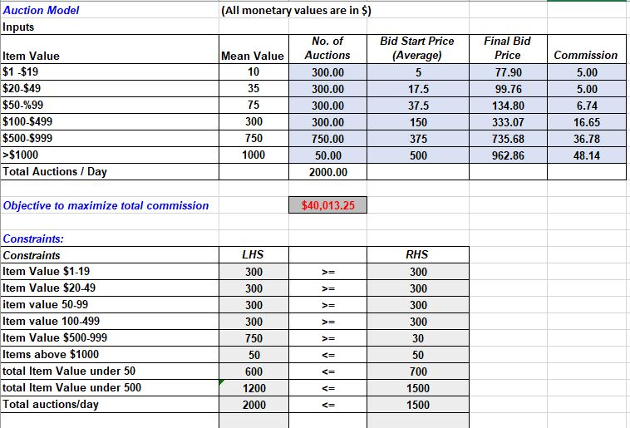

Objective functions = $ 40013.25

In this all our constraints met and Item Value greater than 750 and Total Value under $ 50 is non-binding solutions.

**ONE WAY ANALYSIS FOR SOLVER MODEL IN CUSTOMER CENTRIC WORKSHEET:**

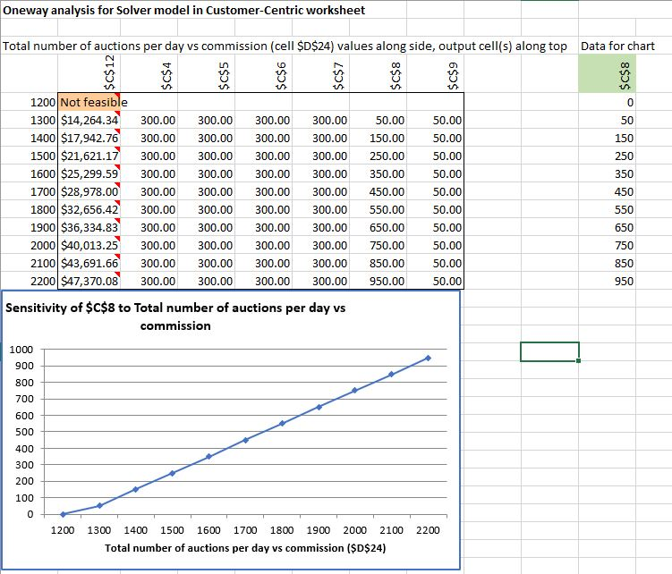

**INTERPRETATIONS**

At auction number 1200 and below the objective function is violating one of the constraints, therefore it is not feasible. As the total number of auctions per day increases from 1300 to 2200 (increment of 50), we can see that objective function increases by a constant amount of $3678, thus the objective function is sensitive to variations in the total auctions per day (input parameter).

For the decision variables of $01 to $499 (cell C4 to C7) the objective function is insensitive to variations in the 'total auctions per day' (input parameter). For the decision variable of $500 to $999, (cell C8) the objective function is sensitive to variations in the 'total auctions per day' ( input parameter). As the total number of auctions per day increases from auction 1300 to auction 2200 (increment of 100), we can see that objective function increases by a constant amount of $3678, thus the objective function is sensitive to variations in the total auctions per day (input parameter). For the decision variables greater than $1000 (cell C9), the objective function is insensitive to variations in the 'total auctions per day' (input parameter).

**TWO WAY ANALYSIS FOR SOLVER MODEL IN CUSTOMER CENTRIC WORKSHEET:**

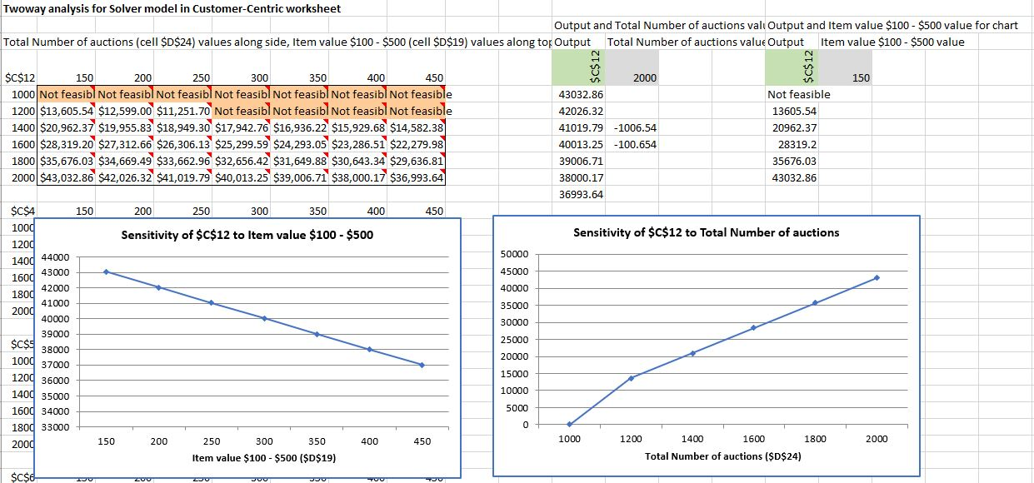

**INTERPRETATIONS**

1) CellC12 is the objective function. When item value is between $100 to $499 and total auction number per day is 1500, the objective function is decreasing by a constant amount of $1006, thus we can see that objective function is sensitive to variations in the total auctions per day (input parameter). There is a negative effect on the objective function.

2) CellC12 is the objective function. When the total number of auctions increased 1200 to 2200, the objective function is increasing by a constant amount of $7356, thus we can see that objective function is sensitive to variations in the total number of auctions per day (input parameter). There is a positive effect on the objective function which indicates that having more number of auctions will lead to higher commission.

**CONCLUSION**

**Strategy A:**

In this strategy, the objective function of maximizing the commission is **$15,544.60**. We can observe from the one-way sensitivity analysis for High Value listings, as the total number of auctions per day increases from 300 to 750 (increment of 50), we can see that objective function increases by a constant amount of $2407, thus the objective function is sensitive to variations in the total auctions per day (input parameter). The graph shows an increasing (positive) trend. Therefore, by increasing the total number of auctions per day, we can expect higher commission. Business recommendation is to have a greater number of auctions per day as the company can earn higher commission then.

We can observe from the two-way sensitivity analysis for High Value customers, when ‘item value is $100 to $499’ (and the constraint variation is between 25 to 75), the objective function is decreasing by a constant amount of $157.45, thus it will not be an advantage to the company to have more number of auctions with price item listed between $100 to $499. Business recommendation is to not have a greater number of auctions per day in this category.

**Strategy B:**

In this strategy, the objective function of maximizing the commission is $**40,013.25**

We can observe from the one-way sensitivity analysis for Customer Centric strategy, as the total number of auctions per day increases from 1300 to 2200 (increment of 50), we can see that objective function increases by a constant amount of $3678, thus the objective function is sensitive to variations in the total auctions per day (input parameter).

We can observe from the two-way sensitivity analysis for Customer Centric strategy when ‘item value is $100 to $499**’** (and the constraint variation is between 150 to 450) and total number of auction per day is 1500, the objective function is decreasing by a constant amount of $1006.54, thus we can see that objective function is sensitive to variations in the total auctions per day (input parameter). There is a negative effect on the objective function.

**RECOMMENDATION:**

Based on our analysis, no matter which strategy EastBay Inc. chooses, the category of ‘price item value $100 to $499’ is resulting in a decreased value of objective function, thus the company should limit the total number of auctions allowed in this category.

For the strategy A of high value customers, ‘item value $100 to $499’ category, if we increase the number of auctions by 5 we will lose $157.45. For strategy B of Customer Centric, ‘item value $100 to $499’ category, if we increase the number of auctions by 5 the company will lose $100.65. Based on this analysis, one can observe that the company is losing less money for strategy B for ‘item value $100 to $499’ category.

For the strategy A of high value customers, the objective function of maximizing the commission is $15,544.60 but the total number of daily auctions is limited to 500 auctions only. For the strategy B of Customer Centric strategy, the objective function of maximizing the commission is $40,013.25 but the total number of daily auctions is limited to 1500 auctions. For this to happen, the company needs to have 1.5 auction per minute which is a challenge initially since the company is new. We can notice the difference in the total number of daily auctions allowed for each strategy.

Our business recommendation for EastBay Auctions Inc. is for the company to focus on strategy A initially because the company has no brand recognition and getting 1500 auctions per day is a challenge since not many people are aware of the company. After EastBay Auctions Inc. has been established in the market and there is strong brand recognition, then the company can focus on Strategy B as the company can attract 1500 auctions per day.

No matter what strategy is chosen, EastBay Auctions Inc. should limit the number of auctions in the ‘item value $100 to $499’ category because the company will not be generating maximum commission in this category as mentioned above.

